PetSafe: An Environment Enabled Collar For Active Pet Monitoring

Samhruth Ananthanarayanan – 21BCE1791  
School Of Computer Science And Engineering  
Vellore Institute Of Technology - ChennaiChennai, India  
samhruth.ananth2021@vitstudent.ac.in

*Abstract*— Pets often find themselves in environments that may not be suitable for their physical build or health conditions. Such situations, while unintentional, can lead to severe health repercussions. These unfavorable conditions can be difficult for pet owners to detect immediately, as the subtle effects of environmental stressors often go unnoticed until they manifest as health issues. However, with proactive monitoring, these risks can be mitigated or entirely avoided. Early identification of these factors can prevent long-term health complications, ensuring pets thrive in their surroundings.

Currently, most electronic pet collars focus solely on monitoring internal factors such as heart rate, body temperature, and activity levels to provide insights into a pet's well-being. While valuable, this approach overlooks the significant influence of external environmental factors such as temperature, humidity, air quality, and sunlight exposure. These external elements often interact with a pet's physiological responses, potentially exacerbating health risks or triggering specific issues. For example, high humidity coupled with elevated body temperatures may predispose pets to heatstroke, a condition that could otherwise be preventable with proper monitoring.

This paper proposes a novel solution: PetSafe,a smart collar capable of simultaneously monitoring both internal and external factors. By integrating environmental sensors with physiological monitoring systems, the collar enables a comprehensive view of a pet's health. The combined data allow for corroborating internal and external mechanisms to identify potential risks. This dual-layered approach provides real-time alerts and actionable insights for pet owners, allowing them to make informed decisions about their pet’s environment and care. This proactive system not only improves the accuracy of health assessments but also enhances overall pet safety. Such a collar would set a new standard for pet monitoring technology, ensuring that pets remain in environments conducive to their optimal health and well-being.

Keywords—collar, external factors, health, monitor

# Introduction

Many people worldwide rely on pet monitors and electronic collars to simplify the process of monitoring their pets. These devices have become increasingly popular as more individuals transition back to designated workplaces, leaving their pets unsupervised for extended periods. In such scenarios, keeping track of a pet’s health, behavior, and activity levels becomes challenging, making pet monitors a valuable tool for pet owners.

The growing adoption of pet monitors stems from their ability to provide real-time updates on a pet's well-being, even from a distance. These devices often come equipped with features like GPS tracking, activity monitoring, and health indicators, allowing owners to ensure their pets are safe, active, and healthy. Additionally, some advanced monitors offer environmental monitoring, such as temperature and humidity levels, ensuring pets are in comfortable conditions. By offering convenience and peace of mind, pet monitors are transforming how owners care for their pets in today’s busy world.

## Monitoring Pet Actitivity

* Monitoring pet activity is essential for maintaining their physical and mental well-being, particularly for active animals like dogs and cats. Regular exercise is vital for their health, and electronic monitors provide a reliable way to track daily steps, playtime, and rest periods. These insights help owners determine whether their pet is meeting its activity needs. By identifying patterns of inactivity or overactivity, owners can adjust their routines to ensure their pets remain healthy and stimulated.
* For pets recovering from injuries or surgeries, activity monitors offer an added layer of care. They help ensure the pet is not overexerting itself during the recovery process, which could potentially slow healing or lead to complications. Tracking rest and controlled movement becomes significantly easier with these devices, giving owners peace of mind and allowing veterinarians to assess recovery progress more effectively.
* Additionally, many modern pet activity monitors integrate seamlessly with smartphone apps. These apps provide detailed visual reports of a pet’s energy patterns over time, making it simple for owners to detect changes or trends that might indicate underlying health issues. By leveraging this technology, pet owners can make data-driven decisions to improve their pet's overall quality of life, ensuring their furry companions stay active, happy, and healthy.Health Tracking
* Advanced electronic monitors now come with sensors that measure vital health metrics, such as heart rate, respiration, and body temperature. These features are beneficial for catching early signs of illness or stress.
* Some devices monitor hydration levels or detect changes in a pet’s eating and drinking habits, which can signal underlying health concerns.
* Health tracking is especially valuable for pets with chronic conditions like diabetes or arthritis, where constant monitoring can prevent emergencies.

## Safety And Location Tracking

* GPS-enabled collars or monitors allow pet owners to track their pets' real-time location through a smartphone app. This is particularly useful for adventurous pets that like to roam.
* Geo-fencing technology lets owners set up virtual boundaries; if the pet strays outside the designated area, the device sends an alert.
* For pets in urban environments, these devices can prevent accidents by ensuring they don’t venture into dangerous areas like busy roads.
* Some monitors can detect and log unusual behaviors, like excessive barking, scratching, or pacing. These patterns might indicate stress, anxiety, or physical discomfort.
* For dogs prone to separation anxiety, monitors with cameras and microphones can help owners observe how the pet behaves when alone. Some even allow real-time interaction to soothe the pet.
* Understanding behavior helps in training efforts, as owners can identify triggers for bad behavior and take corrective action.

## Convenience For Busy Owners

* For busy pet owners, modern monitoring devices offer unparalleled convenience, allowing them to stay connected with their pets regardless of their location. With remote access capabilities, owners can monitor their pets while at work, traveling, or running errands. This real-time reassurance is particularly beneficial for new pet owners or those with young animals who require extra attention. Knowing their pets are safe and well-cared for provides peace of mind and reduces stress.
* Many pet monitors also come equipped with two-way communication features. These devices enable owners to speak to their pets directly, which can be invaluable in moments of distress or separation anxiety. Hearing a familiar voice can calm pets, redirect their attention, or even deter undesirable behaviors like excessive barking or scratching. This feature helps maintain a sense of connection, even when owners are physically apart.
* Additionally, some monitors integrate with automatic feeding systems, ensuring that pets are fed on schedule even when their owners are away. These systems can confirm whether the meal was consumed, providing another layer of reassurance. This combination of monitoring and automation supports a pet’s daily routine, helping owners manage their responsibilities while ensuring their furry companions receive the care and attention they deserve.Veterinary Integration
* Many monitors allow data syncing with veterinary apps or platforms, creating a continuous health record for pets. This assists in diagnosing and monitoring chronic illnesses.
* During recovery periods after surgeries or illnesses, vets can review activity, sleep, and other health data remotely to adjust treatment plans.
* Alerts for abnormal vitals can prompt timely medical intervention, potentially saving lives in critical situations.

## Special Needs Pets

* Caring for special needs pets requires extra attention and tailored support, and modern monitoring devices can significantly simplify this task. Older pets often face mobility challenges, joint pain, or declining health. These monitors can track their activity levels, rest periods, and other behavioral changes, helping owners and veterinarians identify issues early and adjust care routines accordingly. By monitoring their condition in real time, owners can ensure aging pets receive the right support to improve their comfort and quality of life.
* For pets with chronic conditions like epilepsy or diabetes, these devices offer critical life-saving capabilities. Equipped with real-time alerts, they can notify owners of emergencies such as seizures, low blood sugar levels, or other warning signs. This immediate feedback allows for quick intervention, potentially preventing serious complications or even saving the pet’s life.
* Disabled pets, such as those with limited mobility or sensory impairments, often require constant observation to ensure their safety. Monitoring devices simplify this process by providing regular updates and alerts when the pet encounters difficulties or requires assistance. Whether it’s detecting abnormal activity or ensuring the pet remains in a safe area, these devices enable owners to provide consistent, attentive care, ensuring their special needs pets lead happy and supported lives.

## Household Management

* Managing a multi-pet household can be challenging, especially when trying to ensure that each pet’s needs are met. Monitoring devices offer a practical solution by helping owners track individual pets’ behaviors, food intake, and activity levels. This is particularly important when one pet tends to dominate shared resources, such as food or attention. By identifying imbalances, owners can intervene to ensure all pets receive equal care and support.
* Tracking devices are also invaluable for pinpointing specific behaviors within a group of pets. For instance, if a pet is marking areas, overeating, or displaying unusual aggression, these devices can help identify the culprit. Understanding which pet is exhibiting a behavior allows owners to address the issue more effectively, whether it’s through training, dietary adjustments, or seeking veterinary advice.
* Additionally, these devices enable owners to monitor interactions between pets, offering insights into their relationships. In households with new or introduced pets, tracking interactions can help prevent conflicts and ensure they are bonding well. Alerts for signs of tension or aggressive behavior allow owners to step in before issues escalate, promoting a harmonious environment.
* By offering detailed, individualized insights, monitoring devices make it easier to manage multi-pet households, ensuring each animal’s well-being while fostering positive relationships among all members of the home.

This presents the applications of the collar as used in everyday life and possible implementations of this paper.

# Literature Review

Maggi and Krämer (2019) highlights the prevalence of vector-borne diseases in pet animals across Latin America. It discusses the role of vectors like ticks and fleas in transmitting pathogens, emphasizing the lack of veterinary healthcare and public awareness in some regions. The article suggests better control measures and collaborative research to mitigate disease risks. [1]

Nikula et al. (1992) investigates the effects of ultraviolet (UV) radiation on Beagle dogs, examining its role in solar dermatosis and cutaneous neoplasia. The findings reveal that prolonged UV exposure can induce skin damage and increase the risk of skin cancer, drawing attention to the importance of protective measures for dogs exposed to high UV levels. [2]

Salonen et al. (1991) explores how air temperature and humidity affect tracheal vascular and smooth muscle responses in dogs. It demonstrates that colder and dryer air can trigger physiological changes, providing insights into respiratory health under environmental stressors. These findings are valuable for managing respiratory conditions in pets. [3]

Chung et al., (1985) examines the link between antigen exposure, airway hyperresponsiveness, and pulmonary inflammation in allergic dogs. It highlights that allergen exposure can lead to significant respiratory distress, underscoring the importance of identifying and managing allergens in sensitive breeds. [4]

Verlinden et al. (2007) details the prevalence and symptoms of food allergies in dogs and cats, analyzing common allergens such as beef, dairy, and chicken. The authors advocate for elimination diets and tailored nutritional strategies to mitigate symptoms like itching, gastrointestinal distress, and chronic ear infections. [5]

Almazan et al. (2020) states that the CAHM system is an IoT-based platform designed to monitor the health of companion animals. It integrates sensors and mobile applications to track parameters such as temperature, heart rate, and activity levels. The system offers real-time updates and alerts, enhancing preventive care and early detection of health issues. [6]

Turner et al. (2022) evaluates biomarkers associated with anaphylaxis in dogs stung by insects. It identifies allergy, inflammation, hepatopathy, and coagulation markers, contributing to diagnostic and therapeutic approaches for acute allergic reactions in veterinary medicine. [7]

Dávila et al. (2018) outlines guidelines for diagnosing and managing allergies in dogs and cats. It categorizes allergic conditions such as atopic dermatitis and food allergies and offers recommendations for immunotherapy and environmental control. [8]

Little (2021) provides a comprehensive overview of fleas and lice affecting dogs and cats. It covers the lifecycle, infestation patterns, and disease transmission risks associated with these ectoparasites, stressing the need for integrated pest management strategies.

Saleh et al. (2021) reviews tick species infesting dogs and cats in North America, focusing on their biology, geographic distribution, and pathogen transmission. It highlights the role of ticks as vectors for diseases like Lyme disease and ehrlichiosis, emphasizing preventive care through tick control measures.

# Proposed Methodology

The project aims to use external factors such as sunlight, external temperature of the environment and humidity as key factors to evaluate a pet’s health. For the simplification of this application, the paper will focus on dogs only. The aim of this project is to be able to use the external factors to try and diagnose internal issues with the dog in question.

The dog in question being tested is the author’s own pet dog pictured below.

  
*Fig 1. Sudo, the dog in question*

## Main Collar Section

The PetSafe collar itself is electronically enabled and consists of a standard collar with a microcontroller and several sensors attached to it in order to be able to facilitate the reading of the dog’s vitals. The main purpose of the microcontroller is to act as a central node for each sensor. The components used are listed in the table below

# Table 1. Component List

|  |  |  |
| --- | --- | --- |
| **Component Type** | **Component Name** | **Function** |
| Microcontroller | ESP32 | Main controller node needed for collection and processing of data |
| Humidity And Temperature Sensor | DHT11 | Senses temperature and humidity of external environment |
| Sunlight Sensor | LDR | Checks for sunlight present In environment |
| Pulse Oximeter | MAX30102 | Checks for heart rate and blood oxygen level of the dog |
| Accelerometer | MPU9250 | Checks for movement and body temperature of the dog |

All sensors are connected via breadboard to the ESP32 in which case the breadboard can be used as a mounting point for the rest of the sensors to be able to do their work as needed. The ESP32 microcontroller can handle the conversion of inputs to digital inputs from any analog signals using inbuilt ADCs and such to make sure that all values are numerically output

The DHT11 and Sunlight Sensor both have digital outputs and can be directly connected to an input pin of the ESP32. The Pulse Oximeter and Accelerometer however are more complex and need to establish I2C connections with the master ESP32 coordinator. For this, they need master clock synchronization and slave clock speed initialization along with the sending of their slave addresses to the master node in order to communicate their data.

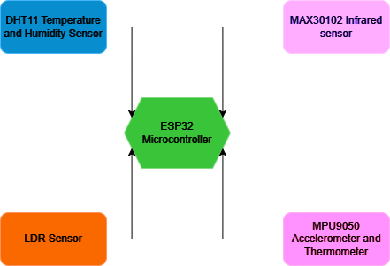  
*Fig 2. Architecture Of Sensor Node*

## Bluetooth Connection

The ESP32 will be connected to the computer via a Bluetooth Low-Energy or BLE connection. All data is transmitted via serial port using a string format with spaces in order to preserve the information as it is and retrieve it by simply splitting the string via spaces in order to get the values back.

The use of Bluetooth Low Energy allows for pairing of devices to create a 1-1 master-slave connection between the phone and the receiver to be able to monitor the pet while in close proximity such as walking or any other such behaviours. The processing of conditions and warnings to be given to the user can also be done on the phone itself. The phone is also connected to a live realtime database in order to retrieve data when the owner is away from the pet.

## Realtime Database

The realtime database stores data from the pet over long periods of time in order to extract data as needed. It is connected to the phone via the internet using WiFi or Mobile Data and acts as a cloud storage for data to be sent after processing on the phone itself. It also acts as a data hub for when the phone is too far away from the pet to be transmitting data using Bluetooth.

## Disease Detection

The collar also uses oxygen, heart rate and multiple other factors to be able to diagnose a few diseases such as heart attacks, strokes, lung disorders and allergies. All of these are implemented using thresholds taken from observations.

## Overall Architecture

The overall architecture followed by PetSafe is a three tier MHealth architecture involving an edge device which is the microcontroller and the sensors, a fog device connected to the edge device which is the phone connected via BLE and the cloud database which is connected using the internet.

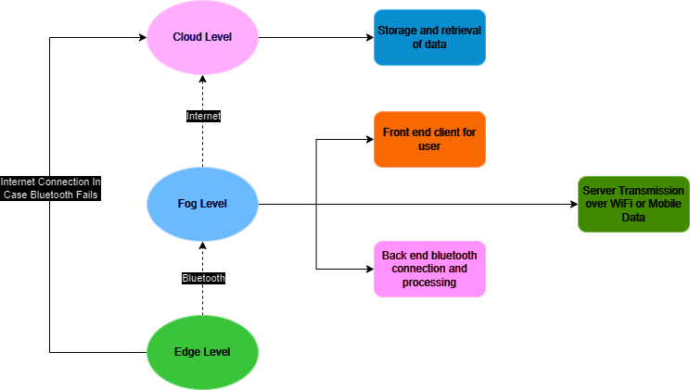

*Fig 3. Overall Architecture of System*

# Implementation

The code for the sensor node was written in Arduino IDE and transferred to the ESP32 Microcontroller using the Serial UART connection for running the code and powering the microcontroller.

The Bluetooth connection and data processing were done in Python along with the connection to Thingspeak over WiFi. The main use of the python program is to create a 1:1 socket with the collar to be able to receive data smoothly and process each data point before transmission.

# Results

The main testing was done using three main phases, one during resting, one during walking and one during running. The resting phase involved idleness, eating and sleeping. The walking phase involves shifting or moving around the house, walking during playing and walking outside. The running involved running during playing and running outside.

The vitals for the test are given below. The data used is averaged over 156 readings.

# Table 2. Results of Readings During Rest

|  |  |  |  |  |
| --- | --- | --- | --- | --- |
| **Activity** | **DHT11(Temp/Hum)** | **LDR** | **MAX30102** | **MPU9250(Acc/Temp)** |
| Idle | 23.26/64 | 0 | 74 | 0.86/38.23 |
| Eating | 25.11/71 | 0 | 85 | 1.13/39.34 |
| Sleeping | 22.15/74 | 0 | 69 | 0.67/38.02 |

# Table 3. Results During Walking

|  |  |  |  |  |
| --- | --- | --- | --- | --- |
| **Activity** | **DHT11(Temp/Hum)** | **LDR** | **MAX30102** | **MPU9250(Acc/Temp)** |
| Shifting | 21.36/71 | 0 | 82 | 4.12/38.48 |
| Playing | 26.71/67 | 1 | 103 | 5.67/39.17 |
| Outdoors | 27.78/73 | 1 | 107 | 5.93/39.65 |

# Table 4. Results During Running

|  |  |  |  |  |
| --- | --- | --- | --- | --- |
| **Activity** | **DHT11(Temp/Hum)** | **LDR** | **MAX30102** | **MPU9250(Acc/Temp)** |
| Playing | 23.45/72 | 0 | 114 | 7.76/38.93 |
| Outdoors | 25.45 | 1 | 123 | 8.04/39.01 |

# Conclusion

The PetSafe collar provides a good baseline to judge whether or not a pet is in any danger or has any underlying health conditions and monitoring active issues or hazards in the environment such as excess sunlight, heat or humidity along with internal issues of heartrate, oxygen, body temperature. It can further provide basic insights for diseases such as allergies, heart attacks or lung disorders.

# Future Work

The proposed pet monitoring system has significant potential for future advancements, leveraging emerging technologies to enhance pet care and safety. As smart devices continue to evolve, the integration of artificial intelligence and machine learning into pet monitors can enable predictive analytics, identifying potential health issues before symptoms appear or improving current health monitoring. These systems could learn an individual pet’s behavior and physiological patterns, providing tailored insights and alerts to owners and veterinarians.

The incorporation of Internet of Things (IoT) connectivity can create a fully integrated ecosystem for pet care. Smart feeders, temperature controls, and even interactive toys could be synced with monitoring devices, providing automated, adaptive care. Owners could control and monitor these systems remotely, ensuring optimal care regardless of their location.

Furthermore, the use of blockchain could improve transparency and reliability in pet health records. Secure, real-time updates from monitoring devices could be directly shared with veterinarians or insurance providers, streamlining medical care and claims processes.

In the long term, these innovations can transform pet care from reactive to proactive, empowering owners to ensure their pets live healthier, safer, and more fulfilling lives. The system’s scalability makes it suitable for households, shelters, and veterinary applications, positioning it as a cornerstone of future pet care technology.

##### References

1. R. G. Maggi, F. Krämer, “A review on the occurrence of companion vector-borne diseases in pet animals in Latin America”, 2019, vol 12, article 145
2. K. J. Nikula, S. A. Benjamin, G. M. Angelton, W. J. Saunders, A. C. Lee, “Ultraviolet Radiation, Solar Dermatosis, and Cutaneous Neoplasia in Beagle Dogs”, 1992, doi: 10.2307/3577898
3. R. O. Salonen, S. E. Webber, M. E. Daffebach, J. G. Widdicombe, “Tracheal vascular and smooth muscle responses to air temperature and humidity in dogs”, 1991, doi: 10.1152/jappl.1991.71.1.50
4. K. F. Chung, A. B. Becker, S. C. Lazarus, O. L. Frick, , A. Nadel, W. M. Gold, “Antigen-induced airway hyperresponsiveness and pulmonary inflammation in allergic dogs”, 1985, doi: 10.1152/jappl.1985.58.4.1347
5. A. Verlinden, M. Hesta, S. Millet, G. P. J. Janssens, “Food Allergy in Dogs and Cats: A Review”, 2007, doi: 10.1080/10408390591001117
6. V. K. B. Almazan, F. I. B. Mahipus, J. R. M. Santos, M. J. C. Samonte, “CAHM: Companion Animal Health Monitoring System”, 2020, doi: 10.1145/3377571.3377641
7. K. Turner, C. Boyd, G. Rossi, C. R. Sharp, M. A. Claus, A. Francis, L. Smart, “Allergy, inflammation, hepatopathy and coagulation biomarkers in dogs with suspected anaphylaxis due to insect envenomation”, 2022, doi: 10.3389/fvets.2022.875339
8. I. Dávila, J. Domínguez-Ortega, A. Navarro-Pulido, A. Alonso, D. Antolín-Amerigo, E. González-Mancebo, C. Martín-García, B. Núñez-Acevedo, N. Prior, M. Reche, A. Rosado, J. Ruiz-Hornillos, M. C. Sánchez, M. Torrecillas, D. P. Kingma, M. Welling, “Consensus document on dog and cat allergy”, 2018, doi: 10.1111/all.13391
9. S. E. Little, “106 - Fleas and Lice”, Greene's Infectious Diseases of the Dog and Cat (Fifth Edition), pg 1324-1337
10. M. N. Saleh, K. E. Allen, M. W. Linberry, S. E. Little, M. V. Richard, “Ticks infesting dogs and cats in North America: Biology, geographic distribution, and pathogen transmission”, 2021, doi: 10.1016/j.vetpar.2021.109392

# Appendix

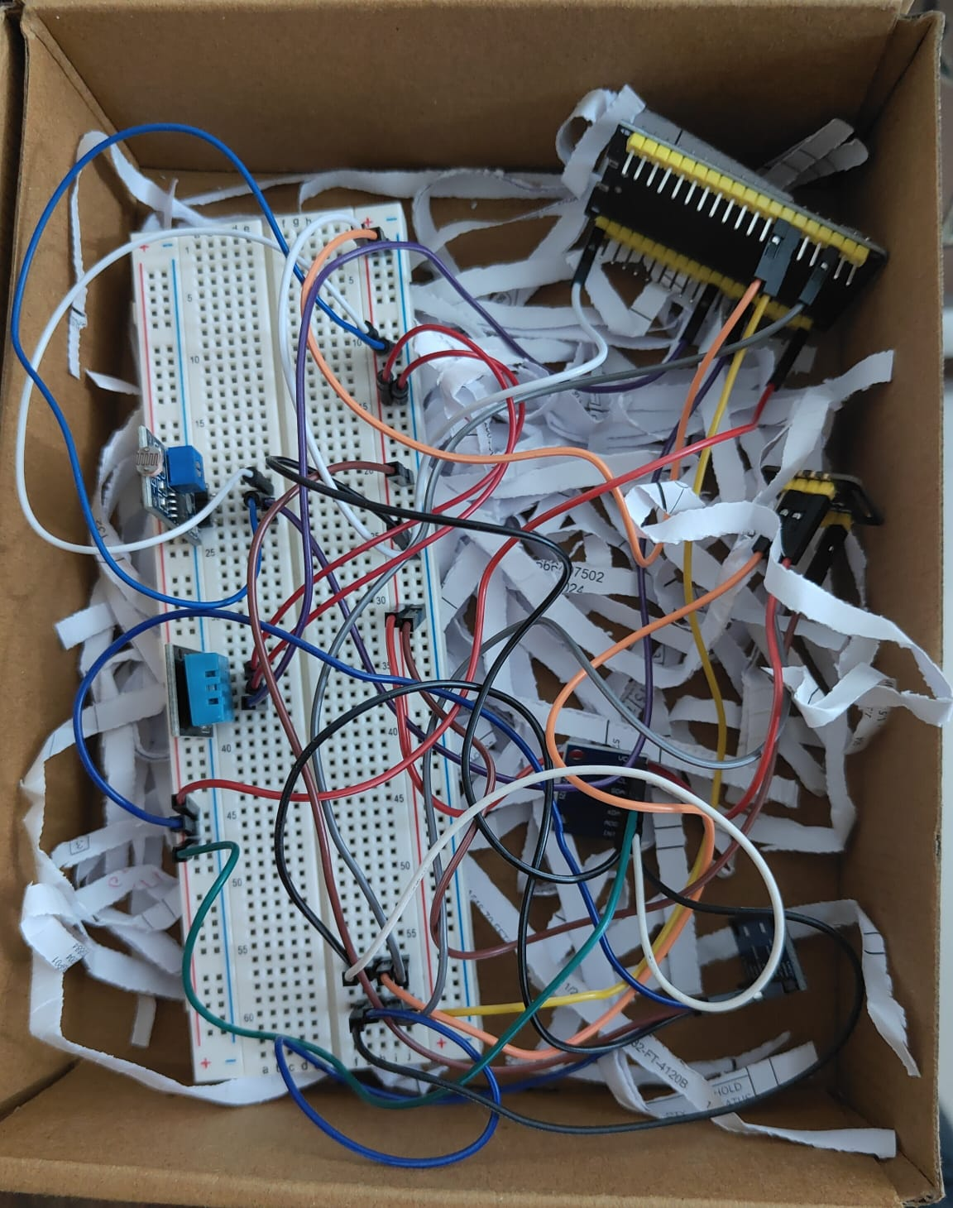  
*Fig 1. Circuit*



*(a)*

  
*(b)*

*(c)*

*Fig 2. ESP32 Code*

**

*Fig 3. Bluetooth Connection*

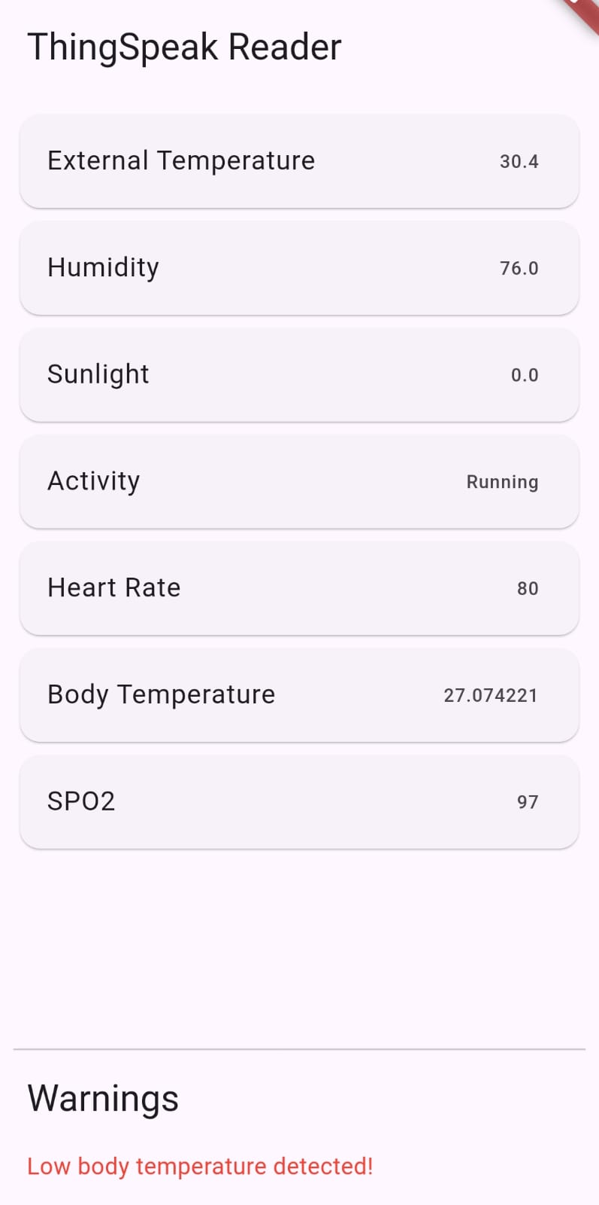

*Fig 4. Mobile App*